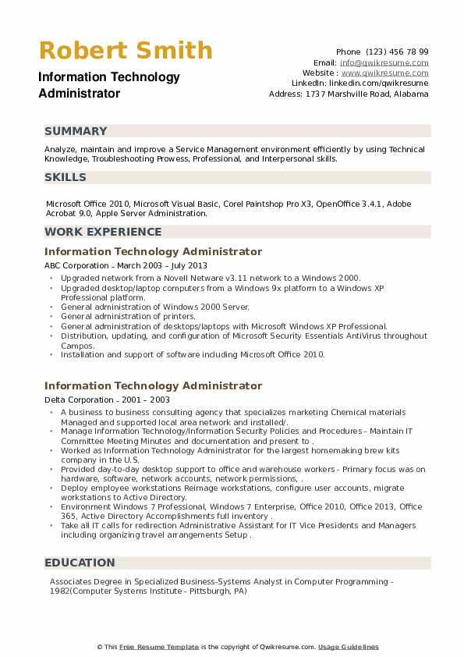
Robert Smith Information Technology Administrator
SUMMARY
Phone (123) 456 78 99 Email: info@qwikresume.com Website: www.qwikresume.com Linkedin: linkedin.com/qwikresume Address: 1737 Marshville Road, Alabama
Analyze, maintain and improve a Service Management environment efficiently by using Technical Knowledge, Troubleshooting Prowess, Professional, and Interpersonal skills.
SKILLS
Microsoft Office 2010, Microsoft Visual Basic, Corel Paintshop Pro X3, OpenOffice 3.4.1, Adobe Acrobat 9.0, Apple Server Administration.
WORK EXPERIENCE
Information Technology Administrator
ABC Corporation - March 2003 - July 2013
⚫ Upgraded network from a Novell Netware v3.11 network to a Windows 2000.
"
Upgraded desktop/laptop computers from a Windows 9x platform to a Windows XP Professional platform..
General administration of Windows 2000 Server.
.
General administration of printers.
.
"
General administration of desktops/laptops with Microsoft Windows XP Professional.
Distribution, updating, and configuration of Microsoft Security Essentials AntiVirus throughout Campos.
Installation and support of software including Microsoft Office 2010.
Information Technology Administrator
Delta Corporation - 2001-2003
⚫ A business to business consulting agency that specializes marketing Chemical materials Managed and supported local area network and installed/..
• Manage Information Technology/Information Security Policies and Procedures- Maintain IT Committee Meeting Minutes and documentation and present to
•Worked as Information Technology Administrator for the largest homemaking brew kits company in the U.S.
"
Provided day-to-day desktop support to office and warehouse workers - Primary focus was on hardware, software, network accounts, network permissions..
Deploy employee workstations Reimage workstations, configure user accounts, migrate workstations to Active Directory.
⚫ Environment Windows 7 Professional, Windows 7 Enterprise, Office 2010, Office 2013, Office 365, Active Directory Accomplishments full inventory.
⚫ Take all IT calls for redirection Administrative Assistant for IT Vice Presidents and Managers including organizing travel arrangernents Setup.
EDUCATION
Associates Degree in Specialized Business-Systems Analyst in Computer Programming - 1982(Computer Systems Institute - Pittsburgh, PA)
This Free Resume Template is the copyright of Qwikresume.com. Usage Guidelines

